**________________________________________________________________________**

**Milestone One**

**Sprint One**

Software Engineering: Processes and Tools

**Sprint Review**

Alana Tobgui (s3760538)

Dan Bound (s3719027)

Gleb Bogachev (s3694543)

Xuan Vo (s781244)

**________________________________________________________________________**

**Sprint:** 1

**Date:** 04/009/2020 **Scrum Master:** Alana Tobgui (s3760538)

**Development Team:**

Alana Tobgui (s3760538)

Dan Bound (s3719027)

Gleb Bogachev (s3694543)

Xuan Vo (s781244)

**Sprint Goals:**

The main aim of the first sprint was to achieve the representation of the booking calendar on the front page. The main functionality of the sprint was to allow administrative functions of adding employees and shifts of the employees.

The general layout of the calendar was organised where it would be present on the home page, while also being large enough to allow multiple available services to be shown per day.

The layout of the administrative page included a calendar to book an employee work slot, and add an employee, with details such as name, age and services provided.

Other presentation related items that were planned during this sprint were the colour pallet and the logo used.

**Status Overview:**

The initial work for the project was relatively easy, as it involved general front end additions, such as a calendar on the front home page for users to book a service with, and to be read for either a logged or non-logged (figure 1). The major aspects of the sprint were allowing functionality for adding an employee via a n admin account, and adding shifts for that crated employee (figure 2, figure 3). It was decided that with the timeframe of this current sprint, that the functionality of having the services allowed displayed on the customer calendar would be implemented in sprint 2, rather than sprint 1.

The presentation of the website was also a major part of the sprint, with the colour pallet being chosen as blues with grey hues, and the logo was also created (figure 4).

**Images:**

**Figure 1**

**Figure 2**

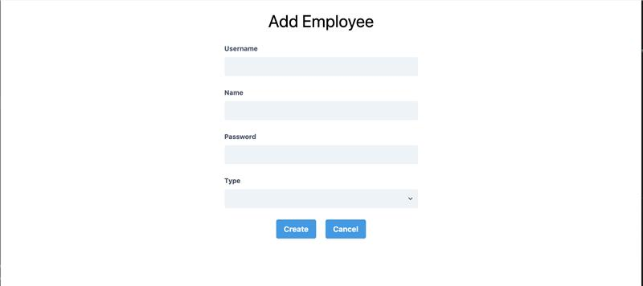

**Figure 3**

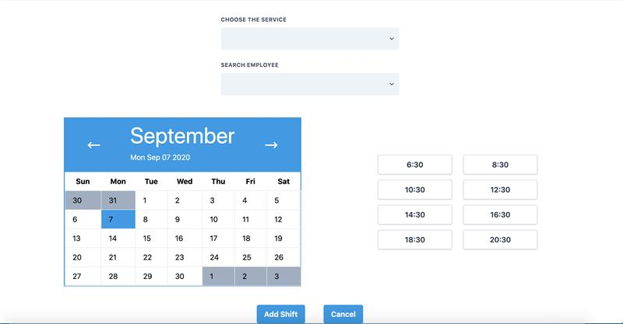

**Figure 4**

**Burndown Chart:**